School of Computer Applications
Department of Master of Computer Applications
SEM Examination Summer – 2026
Semester – II
Class Test – II Practical Exam
Sub Code: 240110203 | Division: D | Total Marks: 50 (including VIVA)
Sub Name: Object Oriented Programming with JAVA (OOPJ)
SET-1
A | ArrayList + Thread Synchronization [20 Marks]  Write a Java program to demonstrate Thread Synchronization using a shared ArrayList.  The program should perform the following:  • Create a shared ArrayList<String> accessible by multiple threads.  • Create 3 threads — each thread adds 3 items (e.g., Thread-1 adds Task-A1, Task-A2, Task-A3).  • Use a synchronized method addItem(String item) to safely add items, avoiding race conditions.  • Each thread displays its name before and after adding items.  • After all threads finish (use join()), display the final ArrayList contents using an Iterator.  • Also display the total size of the ArrayList. | 20
B | Swing – To-Do List Manager [20 Marks]  Design a To-Do List Manager application using Java Swing:  JTextField for entering a new task.  JButton — 'Add Task' and 'Clear All'.  JTextArea (non-editable) to display all added tasks, wrapped in JScrollPane.  JLabel showing total task count (e.g., 'Total Tasks: 3').  On 'Add Task' → append the task from JTextField into JTextArea with a serial number (e.g., 1. Buy Groceries), clear the JTextField, update the count in JLabel.  On 'Clear All' → clear the JTextArea completely and reset count to 0.  Use BorderLayout: input + button at NORTH, JTextArea at CENTER, count label at SOUTH.  Expected Design:  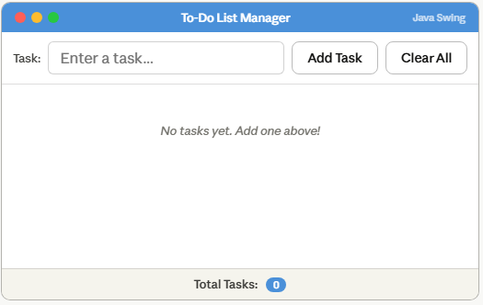 | 20
 | Viva | 10

